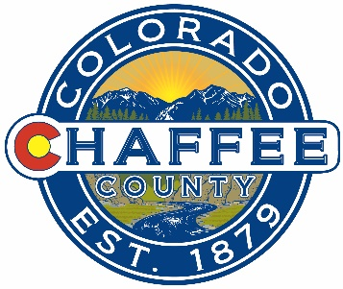

What: Chaffee Common Ground Citizens Advisory Committee Meeting Agenda
Where: Chaffee County Fairgrounds, 10165 CR 120, Salida, CO
When: Monday 26 August
Time: 9:00-11:00AM
Time | Topic | Decisions | Presenting
9:00-9:05 | Consent Agenda  Approval of Minutes of Previous Meetings  Financial Update | Vote to approve
Developing Grant Programs
9:05-10:10 | Round III input on the Rubric with SME input
10:10-10:35 | Plan next steps in developing grant RFPs / possible review of draft example
10:35-10:50 | Initial brainstorm – communicating the programs / key criteria and RFPs to the community
10:50-10:55 | Next Meeting schedule  Deliverable Schedule  September – RFPs to the Community  EO October - Applications due  15 November – Funding decisions
10:55-11:00 | Public Comment and close

