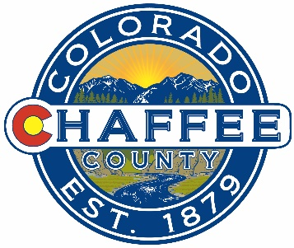
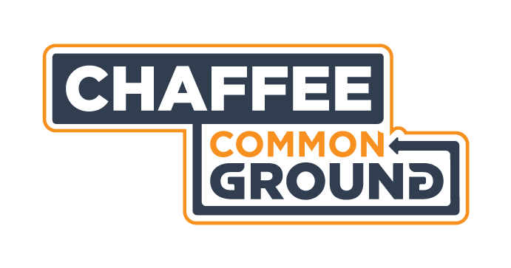

What: Chaffee Common Ground Citizens Advisory Committee Meeting Agenda
Where: Board of County Commissioners Meeting Room, County Administrative Offices, 104 Crestone Ave., Salida, CO
When: Monday 4 November 2019
Time: 9:00-11:00AM
Time | Topic | Decisions | Presenting
9:00-9:05 | Consent Agenda  Approval of Minutes of Previous Meetings  Financial Update | Vote to approve
Foundant On-line Grant Application and Evaluation Forms
9:05-9:30 | Update from Ben D. on current applicants, discussion/decision on any pending questions or concerns.
9:30-10:45 | CAC review of live evaluation process.
10:45-11:00 | Public Comment and close

