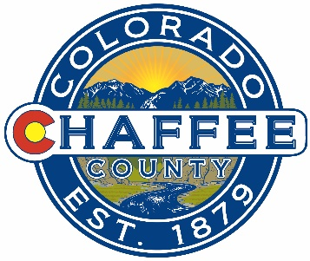
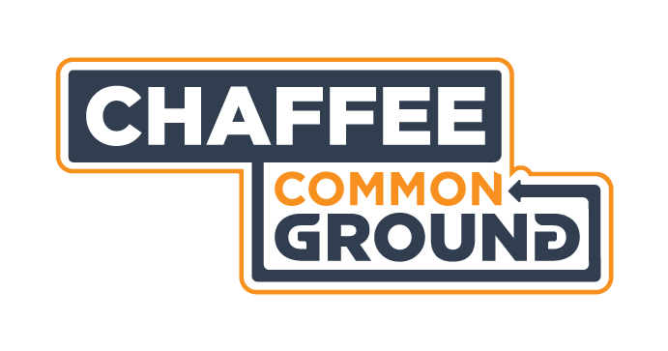

What: Chaffee Common Ground Citizens Advisory Committee Meeting Agenda
Where: Board of County Commissioners Meeting Room, County Administrative Offices, 104 Crestone Ave., Salida, CO
When: Monday 16 December 2019
Time: 9:00-11:00AM
Time | Topic | Decisions | Presenting
9:00-9:10 | Consent Agenda  Approval of Minutes of Previous Meetings  Financial Update | Vote to approve
9:10-9:25 | Review/Agree Proforma Contract Language |  | Cindy
9:25-9:45 | Discuss specific language or conditions by grant. Agree next steps for contracts this year. |  | Cindy
9:45-10:05 | CSFS Grant Errors, Resolution, Lessons Learned and protocol adjustments. |  | Cindy
10:05-10:35 | Community Conservation Connection Grant Applicant meeting. |  | Adam Beh
10:35-10:45 | Discuss feedback received from applicants or community to date and agree on next steps. |  | Ben Doon
10:45-10:50 | Agree CAC Next Steps - Big picture |  | Cindy
10:50-10:55 | Other Business – Next meeting dates |  | Cindy
10:55-11:00 | Public Comment and close

