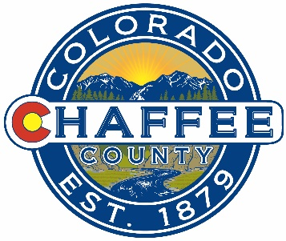
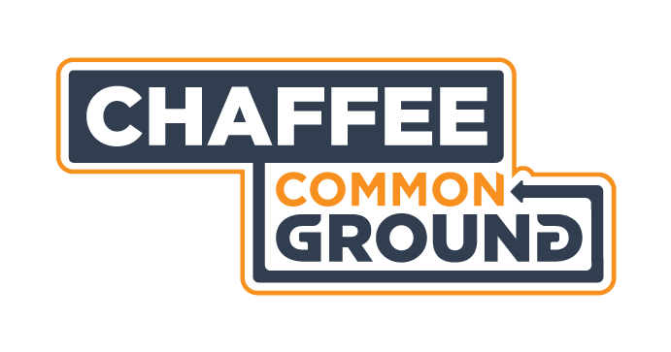

What: Chaffee Common Ground Citizens Advisory Committee Meeting Agenda
Where: Board of County Commissioners Meeting Room, County Administrative Offices, 104 Crestone Ave., Salida, CO
When: Monday 2 December 2019
Time: 9:00-11:00AM
Time | Topic | Decisions | Presenting
9:00-9:10 | Consent Agenda  Approval of Minutes of Previous Meetings  Financial Update | Vote to approve
9:10-9:40 | Feedback for applicants
9:40-10:10 | Lessons Learned
10:10-10:45 | Grant Agreements and Grantee Reporting
10:45-10:55 | Other Business
10:55-11:00 | Public Comment and close

